 | Room #
PI: | Phone #
Biosafety Level 1
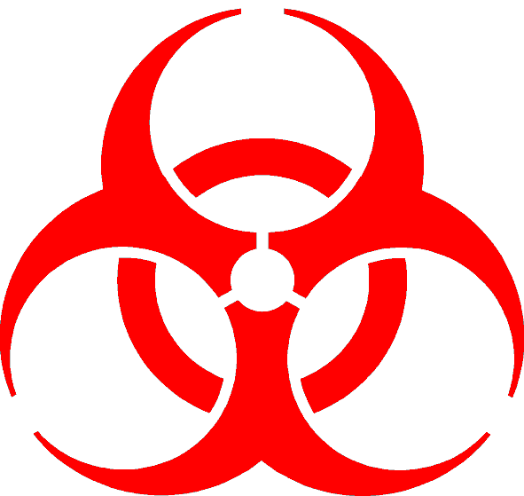
Low Containment / Low Risk
Admittance to Authorized Personnel Only

Research Agent(s):
Personal Protective Equipment:
Emergency Contact
Name | Phone

